¡Bienvenidos a la clase de Español 3 con Profesora Ochea!
Let’s start with some FAQs
What can I expect from Spanish this year?
Most students are pretty nervous to start Spanish 3. Hopefully you’re more excited than nervous, but just in case, here is a quick overview. In Spanish 3 we continue to learn new and more complex vocabulary, and we review all the grammar concepts you did in Spanish 1 and 2 aiming to perfecting those concepts. This does not mean I expect perfection – it means that I expect a concerted effort to improve your Spanish. We will also do some reading, write short essays, play games, talk (a lot), collaborate on projects, act, listen to music and explore some cultural aspects of Spanish-speaking countries and of the language.

So, what will be expected of me?
I expect each and every one of my Spanish 3 students to speak only in Spanish during class, to the teacher, to their peers - all period, every day. English is not to be spoken in class and this rule is strictly enforced. Again, this does not mean that I require perfect Spanish. I fully expect you to make thousands of mistakes and have moments when you don’t know what to say. I want you to try, to act it out, to draw me a picture … basically anything to communicate as much as you can in Spanish. I also expect that all students participate in all activities, collaborate, and give their best effort. I also expect everyone to be kind to each other, provide support to one another and to be respectful of each other and our classroom. I also hope that my students can relax, allow themselves to be wrong, take ownership of their learning, have fun in class and show up with a positive attitude.

What happens if I am COMPLETELY lost???
Please come see me! I will help you in English if you need that extra support – but only during arranged times outside of class – this will be a great use of flex time! There are also LOTS of resources at Skyline and online if you need help. Ask me or check the website if you need help finding extra support.

So I can use Google Translate then?!
Can I really use my phone/tablet?
What do I need for class?

All use of online translators is considered a violation of the Skyline High School Academic Honesty Code and will result in loss of credit. Please use dictionaries in order to find the correct word or phrase to convey your message.
Yes! In general, I encourage the use of internet-connected devices in my classroom! We use them frequently. All students are expected to use their devices responsibly and according to the ISD Personal Device Policy. Your phone/tablet/etc. should be used only for class activities and be put away during assessments or when otherwise directed.
- pencils
- colored pens/highlighters
- paper
- organizer (binder, etc.)
- whiteboard marker*
- old sock*
- internet connected device*
*not required but highly encouraged
What do I need to do if I miss class?
Whether you miss class because you’re sick, have a game, etc. you will need to check my website. On a daily basis, I will post “Lo que hicimos en la clase”, “Lo que vamos a hacer mañana” and reminders for upcoming due dates. If you have any questions, please ask me – but please check the website first. You are the one responsible for making up assignments. Also, if you have a prearranged absence, anything assigned prior to your absence will be expected to be completed by the posted due date unless otherwise arranged with me before your planned absence.
How do grades work?
GRADES
Now on to the BIG question …
How do I get an A?
AKA How do grades work?

Please note that semester grades are earned over the entire semester. If you are concerned about your grade, please come see me as soon as possible if you would like me to either help you with a plan of action or extra support. Once we are more than half way through a semester, it becomes increasingly difficult mathematically for your grade to change.
Quizzes (15%)
Quizzes are a measure of a student’s progress in the unit and should reflect any further practice an individual student may need on any given concept in order to achieve mastery and better prepare for tests.

Final (10%)
There is a cumulative final exam at the end of each semester.

Formal oral (20%)
Formal oral evaluations may include a variety of activities, but they will always be speaking (oral) assignments that students will have time to prepare in advance.

Tests/Compositions (35%)
Tests are considered to be unit assessments and often cover whole chapters. They are used to evaluate mastery of unit concepts. Compositions are written works often in the form of in-class essays or written projects.

Informal oral (20%)
Informal oral evaluations will include conversations in class, use of the Spanish in impromptu situations and other daily speaking assignments.

Any tips on how to get an A / be successful in Spanish?

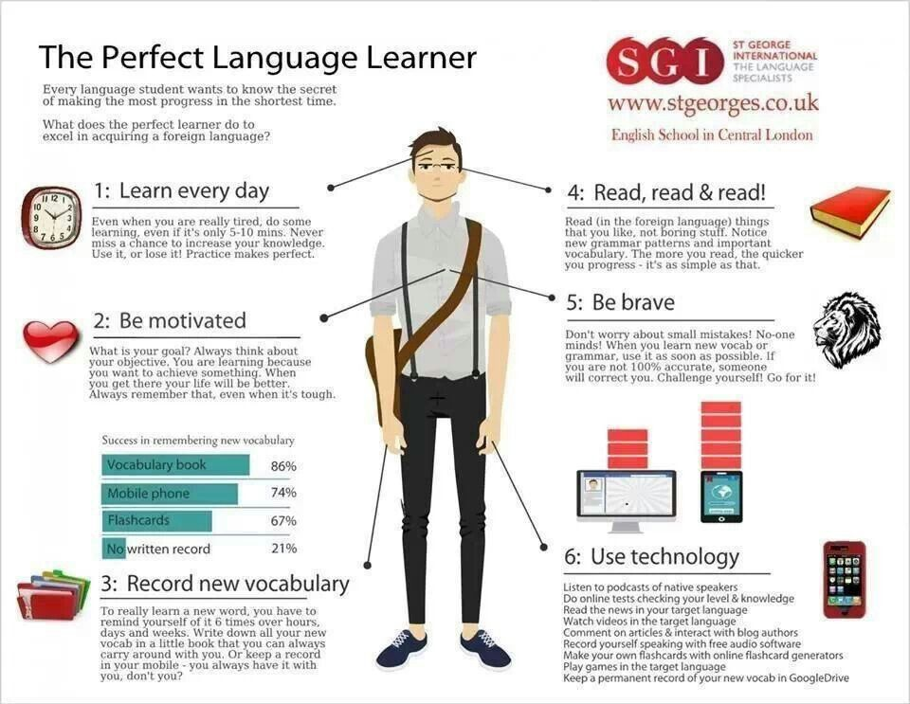
Goals for Spanish 3

I would like for ALL of my students to be successful this year in Spanish 3. Success looks different for everyone, but no matter what you are looking to achieve, setting goals is a huge part of being successful.

Your goals for this year
(What do you want to learn, be able to talk about, or use your Spanish for outside of class?
Your goal may NOT be about any grade.)
Directions: You must complete at least TWO goals. One goal should be for semester one and the second should be a yearlong goal. If you would like to add a third goal (either semester or year), please do! More goals give you more opportunities for success!
1. _________________________________________________________________________________________________
___________________________________________________________________________________________________
2. _________________________________________________________________________________________________
___________________________________________________________________________________________________
3. _________________________________________________________________________________________________
___________________________________________________________________________________________________

Your supervising adult’s space for questions/comments/etc.
(Is there anything you would like me know? Do you have questions for me? This is just an opportunity to leave me a note/question if you feel so inclined. I can always be reached via email/phone at a later time. You can also leave me goals that you would like to see your student achieve this year.)
_________________________________________________________________________________________________
___________________________________________________________________________________________________
_________________________________________________________________________________________________
___________________________________________________________________________________________________
_________________________________________________________________________________________________
___________________________________________________________________________________________________

Once you and your supervising adult have looked over the syllabus and set some goals together, please sign below and return only this sheet to Profe Ochea. Please note that by signing this document you are stating that you understand all rules and policies and are agreeing to abide by all outlined expectations. You are also committing to striving to achieve the goals that you have outlined. Please make sure you are clear on all subject matter that is addressed in this document before signing.

__________________________________________________ __________________________________________________
Supervising adult’s signature and printed name Spanish 3 student’s signature and printed name

